



AWS Solution Architect Training with AWS Cloud Practitioner Global Certification Training

Trainer: Aravindraj.G- Nminds Academy



Configure Fail Over Routing Policy using Route53 in AWS

Aravindraj.G
B.E -Electronics and Communication Engineering
Kongu Engineering College
Erode
Objective
In AWS, a Failover Routing Policy is a DNS routing policy used in Amazon Route 53 to direct traffic to a specific resource when the primary resource becomes unhealthy or unavailable. It allows you to configure a backup resource to take over if the primary one fails, ensuring high availability and fault tolerance for your application.
Here’s how it works:
- Primary Resource: This is the resource that you expect to handle the traffic under normal conditions.
- Secondary (Failover) Resource: This is the backup resource that will be used if the primary resource is unhealthy or fails.
- Health Checks: AWS Route 53 monitors the health of the primary resource via health checks. If the primary resource is marked as unhealthy, traffic is routed to the secondary resource.

Use case example:
- If you have a primary web server running in one region, you can configure a failover routing policy to route traffic to a secondary web server in another region if the primary one goes down. This ensures minimal disruption in service for end users.

Topology
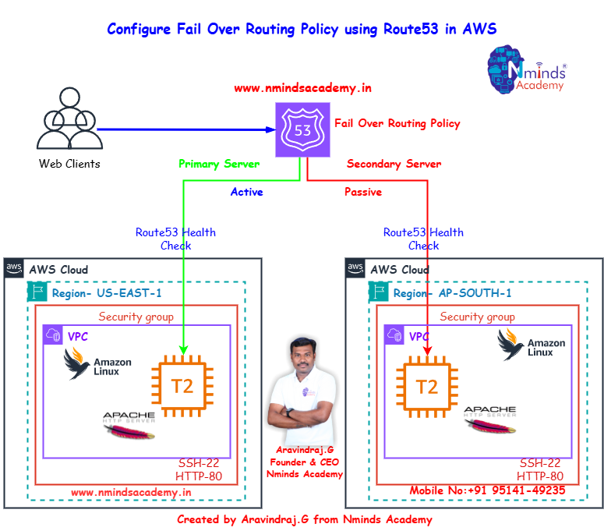

Used Services in AWS Used Services in Linux Server
Apache Webserver

Amazon EC2

Route 53

Execution Tasks:

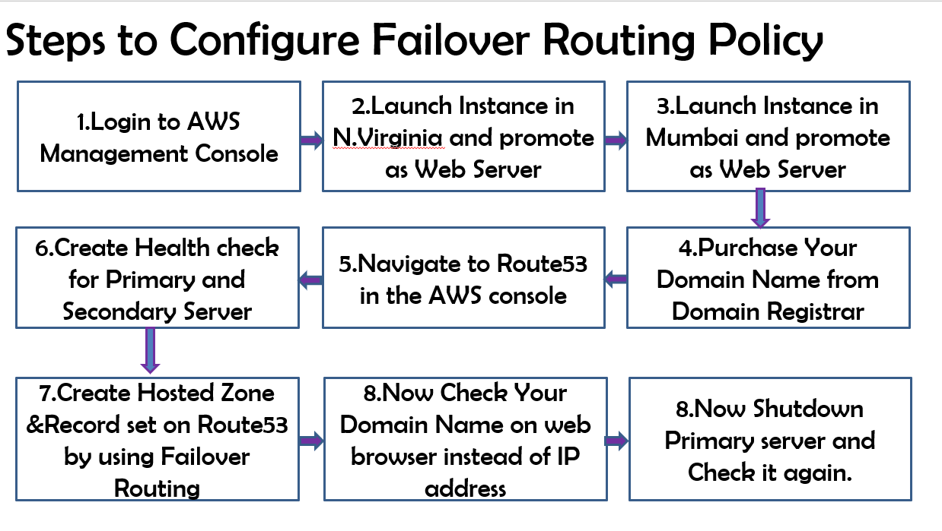

Execution Outputs:

